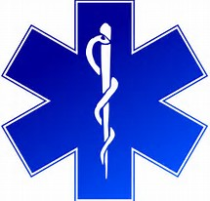

There are many benefits to volunteering at United Communities:
Free training: All EMS training is provided at no cost to you, including CPR certification.
Retirement: County-wide Length of Service Awards
State Tax deduction
Department Incentive Program
County Home Buying Assistance Program for eligible members
A sense of community knowing that you are serving others

The United Communities Volunteer Fire Department is actively recruiting volunteers who are looking to become Emergency Medical Technicians.
Are you interested in Emergency medicine?
Do you want to give back to your community but don’t know how to get started?

The Department is hosting a FREE 165-hour Maryland EMT class this September for all members.
To apply for department membership, visit www.ucvfd.org and download our new member application today!
To learn more about how you can get started volunteering at UCVFD, email our recruiter at recruitment@ucvfd.org.

